MINISTRY OF GENERAL EDUCATION
I/SCIENCE LESSON PLAN
NAME OF TEACHER:________________________ SCHOOL:_____________________
GRADE | TOPIC | SUB TOPIC | DURATION | DATE
9 | ELECTRIC CURRENT AND VOLTAGE IN CIRCUIT | Electric current and Voltage | ____min | ____/___/__
ATTENDANCE: Boys:______ Girls:_______ Total:_____
TEACHING/ LEARNING AIDS : Models, Chalk board, Learners books and Charts.
REFERENCES : I/Science Progress book 9, Study kit I/Science Pamphlet
RATIONALE: This is lesson number one on Electric current and Voltage in the circuit in the series of one. It will help learners acquire skills and values of understanding the difference between electric current and voltage. Group work, discussion, demonstration and Question & Answer methods will be used to execute the lesson.
PRE-REQUISITE SKILLS/ KNOWLEDGE: learners have prior knowledge about Electricity.
SPECIFIC OUTCOMES, LSBAT:
- Explain the difference between electric current and voltage
- Demonstrate the use of an ammeter to measure electric currents in a circuit.
- Demonstrate how to measure potential difference in a circuit.
STAGE | CONTENT | TEACHERS ACTIVITY | PUPILS ACTIVITY | METHODS
INTRODUCTION  ____min | Difference between electric current and voltage.  Electric current is the rate of flow of electrical charged particles. While voltage is electromotive force or potential difference expressed in volts / potential difference is work done in moving the electric charge from one point to another. | Teacher asks random questions to find what they know | Pupils answer and participate during the lesson | Brainstorm
D  E  V  E  L  O  P  M  E  N  T  ___min | The use of an ammeter to measure electric currents in a circuit.  An ammeter is an instrument used to measure the electric current flowing in a circuit. The ammeter in a circuit is connected in series in order to measure the current flowing through a component in a circuit.  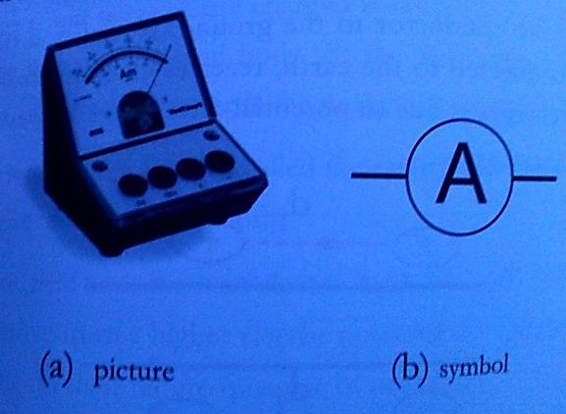  How to measure potential difference in a circuit.  - Voltage is measured in volts using an instrument called voltmeter. The symbol for volts is. A voltmeter is connected in parallel across the components to measure in a circuit. The number of cells affects the voltage across them. The more the number of cells the higher the voltage.  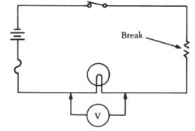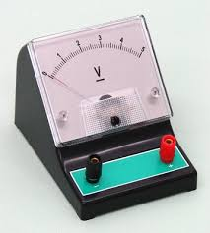  Voltmeter  The relationship between potential difference and current.  - The relationship is ohms law which states that the current (l) flowing through a metal wire is directly proportional to voltage (v) (provided the temperature remains constant). Summary of ohms law R=V/I  LESSON CONCLUSION  The use of electric current in the local environment.  - Lighting in lamps  - Heating in electric irons  - Heating kettles  - Cooking and electric cookers | Teacher explains the details to the learners  Teacher puts pupils in groups to discuss  Teacher writes brief notes on the board  Teacher concludes by explaining the uses of electricity | Pupils listen and ask questions  Pupils discuss and bring out points  Pupils copy the notes in their note books  Pupils listen and ask questions | Teachers  Exposition  Group  work  Individual work  Eclectic method
CLASS EXERCISE / PRACTICAL ACTIVITIES
- Explain the difference between electric current and voltage
- Demonstrate the use of an ammeter to measure electric currents in a circuit.
- Demonstrate how to measure potential difference in a circuit.
ASSIGNMENT/ HOME WORK
PRESSURE
- State what pressure is?
EXPECTED ANSWERS
- Pressure is the amount of force acting per unit area of a surface.
- Pressure = is measured in N/M or Pascal (Pa)
- Pressure is given by P= F/A

- Identify factors affecting pressure in gases?
EXPECTED ANSWERS
- Factors affecting pressure are temperature, amount of the gas and volume.
- Temperature
- Volume
- Amount of gas/ amount of gas particles
PUPIL’S EVALUATION
…………………………………………………………………………………………………
TEACHERS EVALUATION
………………………………………………………………………………………………………………………………………………………………………………………………………….

